EFEE | THE EUROPEAN FEDERATION OF EDUCATION  EMPLOYERS
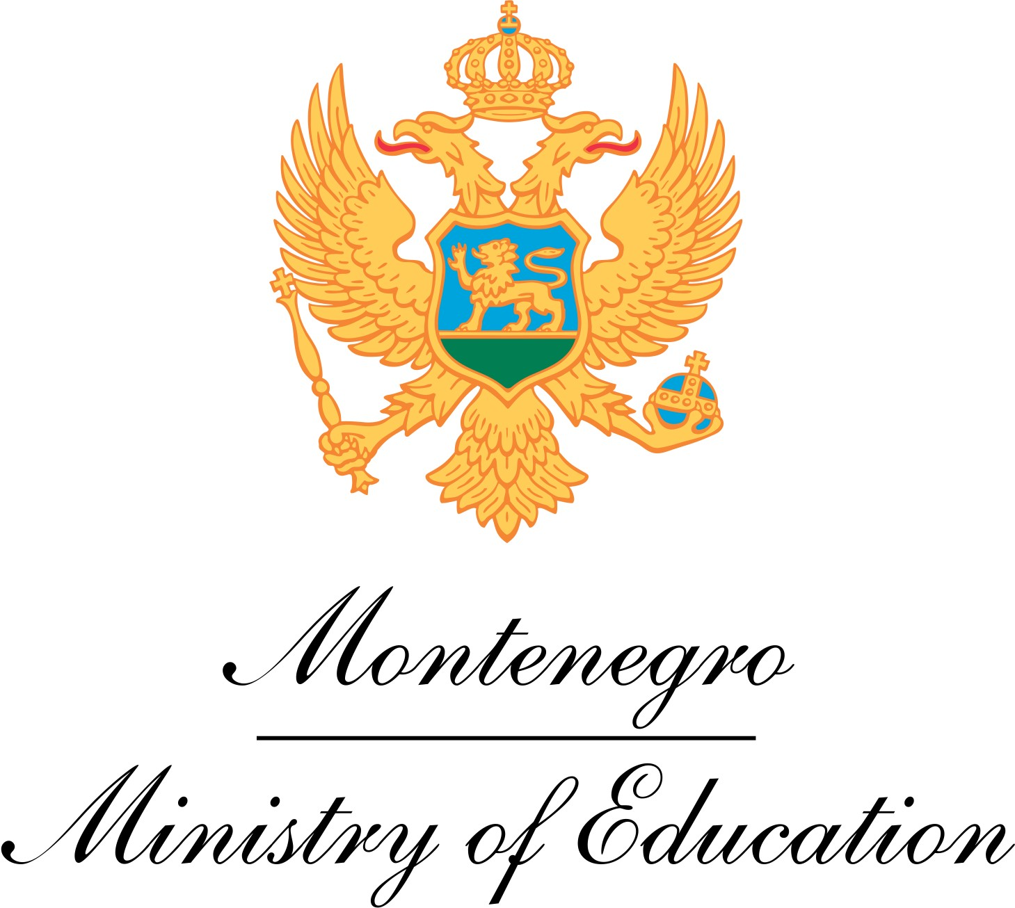

Report EFEE Peer Learning Activity in Montenegro
25 May 2018
PROMOTING AND IMPROVING INCLUSIVE EDUCATION STARTING AT EARLY AGE

On 25 May 2018, the EFEE Peer Learning Visit (PLV) to Montenegro took place in Podgorica on ‘Promoting and improving inclusive education starting at early age’. The event was hosted and co-organised by the Ministry of Education of Montenegro. In total 12 EFEE members and representatives participated in the PLV from Belgium (Flemish and French speaking part), Ireland, Malta, and Slovenia.

Inclusive Education Policies of Montenegro
The participants got insight in the education system of Montenegro by a presentation of Ms Vesna Gajević, Senior Advisor in Cabinet of the Minister. She touched furthermore upon the position of the Ministry of Education as employer in education and the cooperation with teacher trade unions to improve quality education. Subsequently her colleague, Ms Tamara Milić, Head of Division for preschool and inclusive education of the Ministry, presented to the participants the national policies to create an inclusive education system for all. She explained that the policies are based on the four main principles of 1. Human rights; 2. Involvement of family, parents and partners; 3. Individualised support; 4. Special institutions in exceptional severe cases. This means that a ‘regular school’ is in principle always the first choice, also for learners with special educational needs. In case a pupil is in need of additional support, the pupil is assessed by a Commission for Orientation, a team of experts (including a psychologist, special needs educator, social worker, pedagogue) that operate at local community level. The Commission gives advice on the kind of support the pupil would need in school. Furthermore and ‘Individual development-educational program’ is drafted for the pupil in close cooperation with the teacher team, the psychologist, special education teacher, (technical) assistants of the school and respective parents. The individual plan does not only touches upon academic achievements, but also personal and social development goals. The plan is evaluated, and if necessary adapted, twice a year. Moreover, an individual transition plan is set up to ease the transition from primary to secondary education and further onwards (including advice on further education and opportunities at the labour market).

In order to make schools and the learning process accessible to all, the so-called ‘Resource Centres’ play a pivotal role, Ms Milić explained. The teams working at the Resource Centres include social workers, pedagogues, special needs educators, physiotherapists, psychologists, and other relevant therapists (like speech therapists) to provide for a holistic support to kids and parents. The Centres offer a.o. early intervention programmes (for the age of 0 to 6), training for teachers and parents, counselling and advice for schools, and assistive cabinets (like adapted working materials and tools).

Furthermore in order to support schools to cater for the specific educational needs of pupils, the Ministry provides for mobile teams (including speech therapist, special needs educators, psychologists, etc.); promotes peer learning and sharing of good practices among schools on how to improve inclusive education (schools can also share tools and materials via a portal at the website of the Ministry); offers for free adapted working materials (including Daisy and Braille handbooks) and instructive manuals; and provides (technical) assistants for children with special educational needs (like pupils with autism or with physical impairments). Furthermore the Bureau for Education Services of the Ministry, of which Ms Anita Marić was present during the PLV, offers courses for professional development of teachers that include training on inclusive education aspects. The courses are renewed every two year and participation in these courses is a pre-requisite for teachers to be relicensed every 5 year.

The representatives from the Ministry shared their challenges in making inclusive education a reality. It was mentioned that the networking, cooperation and transition within the education system and other relevant systems (like health care, social & employment services, etc.) could be improved, early detection and support to children and their families could be ameliorated, education of personnal could be raised, and accessibility of equitment could be enhanced. In order to tackle these challenges the Ministry set itself three main tasks: 1. Ensure and apply accessibility and equality of education for all students; 2. Ensure and implement the inclusive education continuity from the moment of detection of disability/ difficulties for the full and effective participation in society; 3. Support and improve the quality of inclusive education.

Visit to Primary School
In order to experience how the policies work in practice, the participants of the PLV visited the primary school “21st May” in Podgorica. They talked to the principal, special education teacher, psychologist, teachers, technical assistants and visited classrooms. It was beautiful to see how well the pupils with special needs (in this case mostly pupils with autism) were accepted by their classmates.

Visit to Resource Centres
Moreover the participants visited two Resource Centres in Podgorica: one specialised in the support to children with visual and physical impairments, and one specialised in the support to children with for children with intellectual disabilities and children with autistic spectrum disorders. The participants experiences how therapists and pedagogues work with children with special needs and were informed by members of the assistive team how they provide support to children with autism, their parents, but also to their teachers at school regarding communication challenges. Furthermore the particants were informed by the director of the Resource Centres on the services that are offered to the children, parents, siblings, and teachers: including the aforementioned early intervention programme, individual treatments (speech therapy, psychomotor re-education, special needs education, psychological therapy), cooperation/professional support/counselling and education for parents and families, social and medical services, and (education) tools and materials. Furthermore the Resource Centres provide, through mobile services of support and in cooperation with the Bureau of Education Services of the Ministry, professional assistance and counsellling to school teaching staff working with children with special educational needs, also at pre-primary level. Besides these activities, the Centres also offer classes at primary education level and middle vocational education level to children with special educational needs (in the exceptional cases that the children can’t attend regular schools or in addition to the regular classes).

Peer Learning and Conclusions
These national practices from Montenegro inspired members of EFEE to reflect on their own national systems and to discuss how employers in education can contribute to promoting the inclusion of all pupils in quality education from an early age onwards. It was concluded that early intervention is crucial in order to give children with special educational needs the right support and good basis to ensure their effective equal access to quality inclusive education. It was noted that in Slovenia, Belgium and Malta one is working with such kind of early intervention programmes. For Slovenia it was mentioned however that due to a law-change 5 years ago, pre-schools are now prohibited to inform primary schools on the special education needs of children if no explicit consent is given by the parents, which hampers the transition between both levels for some children, as they only receive additional support when a new assessment has been conducted. Furthermore it was agreed that it would be useful for EFEE and its members to further look into the different inclusive education policies that exist in the EU, as it became clear that in each country different definitions, approaches and implementation practices are being used. It was mentioned that it would be valuable for EFEE members to initiate for example a project to collect best practices in this regard and to promote further peer learning by exchanging local, regional and national practices.

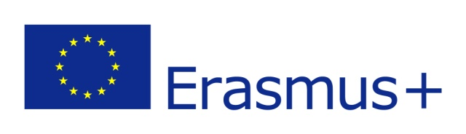
With the support of the ERASMUS+ Programme of the EU

